JURNAL MODUL 12

Nama : Zhafir Zaidan Avail

NIM: 2311104059

Hasil Run:

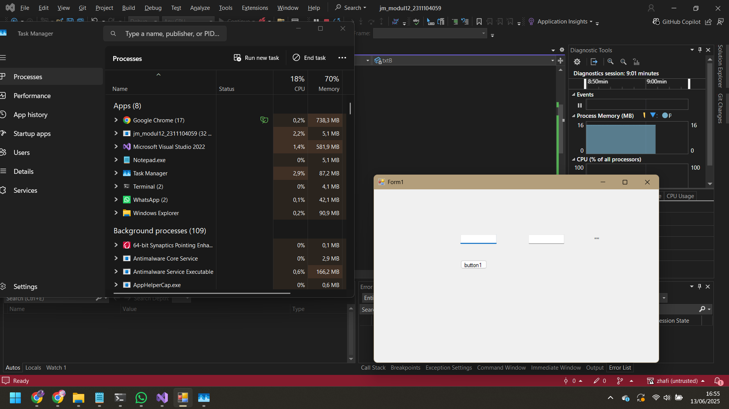

Code Lengkap Form1.cs:

using System;

using System.Windows.Forms;

namespace modul12_2311104059

{

public partial class Form1 : Form

{

public Form1()

{

InitializeComponent();

}

private void btnHitung_Click(object sender, EventArgs e)

{

int a = int.Parse(txtA.Text);

int b = int.Parse(txtB.Text);

int hasil = CariNilaiPangkat(a, b);

lblHasil.Text = $"Hasil: {hasil}";

}

public int CariNilaiPangkat(int a, int b)

{

if (b == 0) return 1;

if (b < 0) return -1;

if (b > 10 || a > 100) return -2;

try

{

checked

{

int hasil = 1;

for (int i = 0; i < b; i++)

{

hasil *= a;

}

return hasil;

}

}

catch (OverflowException)

{

return -3;

}

}

}

}

MENAMBAHKAN UNIT TESTING:

using Microsoft.VisualStudio.TestTools.UnitTesting;

using modul12_2311104059;

namespace modul12_2311104059Tests

{

[TestClass]

public class UnitTest1

{

Form1 form = new Form1();

[TestMethod]

public void TestB0_Return1()

{

Assert.AreEqual(1, form.CariNilaiPangkat(100, 0));

}

[TestMethod]

public void TestBNegative_ReturnMinus1()

{

Assert.AreEqual(-1, form.CariNilaiPangkat(5, -2));

}

[TestMethod]

public void TestALebihDari100_ReturnMinus2()

{

Assert.AreEqual(-2, form.CariNilaiPangkat(101, 2));

}

[TestMethod]

public void TestBLebihDari10_ReturnMinus2()

{

Assert.AreEqual(-2, form.CariNilaiPangkat(2, 11));

}

[TestMethod]

public void TestValidPangkat_ReturnValue()

{

Assert.AreEqual(8, form.CariNilaiPangkat(2, 3));

}

[TestMethod]

public void TestOverflow_ReturnMinus3()

{

Assert.AreEqual(-3, form.CariNilaiPangkat(100000, 5));

}

}

}